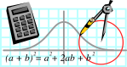  Rossmoyne SHS  Mathematics  Department | MATHEMATICS 3CD | Semester 1 2011  EXAMINATION

NAME:
TEACHER: Mr Birrell Ms Goh Mr Whyte
Mr White Mr Longley Mr Jones

Section Two:
Calculator-assumed

Time allowed for this section
Reading time before commencing work: 10 minutes
Working time for this section: 100 minutes

Materials required/recommended for this section

To be provided by the supervisor
This Question/Answer Booklet
Formula Sheet (retained from Section One)

To be provided by the candidate
Standard items: pens, pencils, pencil sharpener, eraser, correction fluid, ruler, highlighters

Special items: drawing instruments, templates, notes on two unfolded sheets of A4 paper, and up to three calculators satisfying the conditions set by the Curriculum Council for this examination

Important note to candidates
No other items may be taken into the examination room. It is your responsibility to ensure that you do not have any unauthorised notes or other items of a non-personal nature in the examination room. If you have any unauthorised material with you, hand it to the supervisor before reading any further.
Structure of this paper

Section | Number of questions available | Number of questions to be answered | Suggested working time  (minutes) | Marks  available
Section Two:  Calculator-assumed | 10 | 10 | 100 | 80

Instructions to candidates

- The rules for the conduct of Western Australian external examinations are detailed in the Year 12 Information Handbook 2010. Sitting this examination implies that you agree to abide by these rules.

2. Answer the questions according to the following instructions.

Section Two: Write answers in this Question/Answer Booklet. All questions should be answered.
Show all your working clearly. Your working should be in sufficient detail to allow your answers to be checked readily and for marks to be awarded for reasoning. Incorrect answers given without supporting reasoning cannot be allocated any marks. For any question or part question worth more than two marks, valid working or justification is required to receive full marks. If you repeat an answer to any question, ensure that you cancel the answer you do not wish to have marked.
It is recommended that you do not use pencil except in diagrams.

3. You must be careful to confine your responses to the specific questions asked and to follow any instructions that are specific to a particular question.

- Spare pages are included at the end of this booklet. They can be used for planning your responses and/or as additional space if required to continue an answer.
  - Planning: If you use the spare pages for planning, indicate this clearly at the top of the page.
  - Continuing an answer: If you need to use the space to continue an answer, indicate in the original answer space where the answer is continued, i.e. give the page number. Fill in the number of the question(s) that you are continuing to answer at the top of the page.

QUESTION | MARKS AVAILABLE | STUDENT MARK
8 | 5
9 | 9
10 | 11
11 | 6
12 | 9
13 | 6
14 | 5
15 | 10
16 | 13
17 | 6
TOTAL | 80

QUESTION 8. (2,3 marks)

A large number of leaf eating insects are released into a controlled environment to determine
the effect they have on native vegetation . The life span of these insects is relatively short and
the number still alive t days after release is such that,

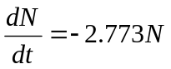

(a) If 200000 insects are released, how many would be expected to be still alive after 4 days?

(b) What is the expected half life of the insects, to the nearest hour?

QUESTION 9. (3,2,2,2 marks)
The local football team the Reds are to play three matches one each week for three weeks.
Based on last years results the probability that they will win the first match is 0.6. In fact every time
they win a match the probability of winning the next match is increased by 0.1. Unfortunately every
time they lose a match the probability of losing the next match is increased by 0.2.
( In this competition a draw is not possible.)

(a) Represent the three matches to be played in a tree diagram, clearly showing the probabilities on
each branch.

(b) Find the probability that they win more matches than they lose.

(c) Given they lost the first match, find the probability that they won the last match.

(d) Given they won exactly two matches, what is the probability that they lost the second match.

QUESTION 10. (1,1,2,2,3,2 marks)

A social tennis club has 27 playing members, of whom 10 are under 30 years of age, 13 are between
30 and 50 years of age and 4 are over 50years of age. If a team of 9 members is to be selected for an
inter club tournament ,

(a) Find the number of ways of selecting this 9 member team if all members are eligible for selection.

(b) Find the number of possible 9 member teams if only one person over 50 is to be selected.

(c) Find the number of possible 9 member teams if an equal number from each age group must be
selected.

Samantha and James are the star players and both are under 30 years of age, while Timothy is over
50 and prone to injury.

(d) How many 9 member teams contain both Samantha and James but not
Timothy and still have an equal number of members from each age group .

(e) Given that Timothy is not selected find the probability that Samantha and James are selected in
a 9 member team.

(f) Given that there is an equal number from each age group, find the probability that Samantha and
James are selected but Timothy is not.

Question 11. (2,4 marks)
A cylinder, open at one end and closed at the other, has a volume of 96 cm. The cost of the
material used for the bottom (circular) end is $3 / cmwhile the cost of the material used to make
the curved part is $2 / cm. There is no waste of material.

(a) Show that the total cost of the cylinder can be expressed as

C = 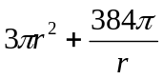

(b) Using calculus techniques , find the dimensions of the cylinder that will minimize the cost .
(You must use a suitable method to demonstrate that your dimensions are in fact minimum.)

QUESTION 12. (2,2,2,3 marks)

Mixed seafood from a north west processing factory is sold in "1 Kg " bags in local supermarkets.
In fact the weight of the seafood in the bags is normally distributed with a mean of 1006 g and a
standard deviation of 5 g. In the following give all probabilities correct to 4 decimal places and all
weights correct to the nearest 0.1 g.

(a) What is the probability that a randomly selected bag of seafood is over the marked weight?

(b) What is the weight exceeded by only 5 % of the bags ?

- If 20 of the "1 Kg " bags are selected at random , find the probability that exactly 4 of them are under the marked weight.

(d) The owner of the processing factory decides that no more than 1 % of the bags should be
underweight . They increase the mean weight of the bags without changing the standard deviation.
What should be the mean weight of seafood to ensure that no more than 1 % of bags are
underweight?

QUESTION 13 (5,1 marks)

Sachin is in training for the Hawaiian Iron Man and knows he need to put time into running (x hours),
cycling (y hours) , swimming (z hours) and visits to the gym (w hours) . He has 100 hours of training time available before the actual event and hires a personal trainer to plan a schedule for him to follow. The schedule states:
- The number of hours spent in the gym must equal the hours spent running and swimming combined.
- The number of hours of cycling must be 10 more than the hours spent running and swimming combined.
- The ratio of the hours spent running to the hours spent swimming must be 2 : 3 .

(a) Write down an appropriate system of linear equations for the given information, in terms of
x, y, z and w .

(b) Solve your system of equations to find the number of hours Sachin spent running, cycling,
swimming and in the gym training before the event.

QUESTION 14 (5 marks)

A small spherical ball bearing has a radius of 2.5 mm . Using differentiation, find the percentage
increase in the surface area , when the radius changes to 2.6 mm.

QUESTION 15 (2,5,3 marks )
For the function F(x) = 4x - 6x- 24x + 40 find ;

(a) The coordinates of the x and y intercepts .

(b) Using calculus techniques find all stationary points and clearly demonstrate the nature of these
points.

(c) The coordinates of any points of inflection.

QUESTION 16. (2,2,2,3,2,2 marks)

The graphs drawn on the axes below have equations:

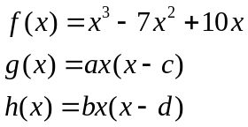

The graphs are not drawn to scale.

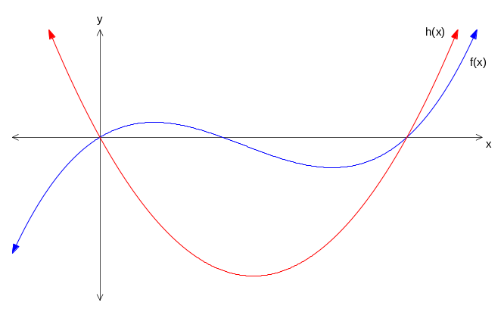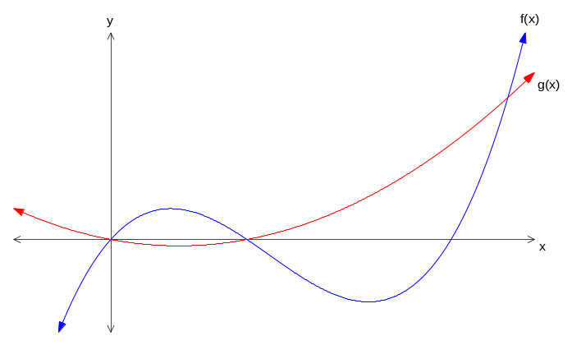

- Determine the values of c and d.
- Use your calculator to find, in terms of a, the largest value of x such that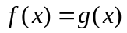.
- Show how this same result can be determined algebraically.
The shaded area between the curves  and  is equal to the shaded area between the curves and 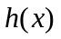.
- Write an equation involving calculus to represent the above statement.
For parts e) and f) consider the case when .
- Find the area of the shaded region between the curves and .
- Use your answers to d) and e) to determine the value of b to 3 decimal places.

QUESTION 17. ( 2,2,2 marks)

Jock, a keen amateur golfer, calculates the probability that he can land the ball on the green of an easy
par 3 to be 0.72. Assuming that the probability remains constant, determine probability that in 30
attempts at this hole he will,

(a) Land on the green exactly 15 times.

(b) Land on the green at least 15 times but not more than 25 times.

(c) If Jock would like the probability he hits the green at least 25 times to be above 0.5,
find the least number of attempts he should make.

